The 2019 annual C/L Combat Graffiti fun fly. By Ken Burdick (send via Larry Lewin & Paul Dranfield)

Yes Folks, it’s true. On a wet July 7, Combat Graffiti was held in Mission B.C. as guests to the most generous Mission Wings. The effort was led by Paul Bedford and lots of help from other members such as Larry and Kathy Lewin. The location is primarily an RC field owned by a local farm and leased for our fun usage. The grounds had been mowed within days of our arrival and looked more like a golf course than a flying field. Combat Graffiti has been hosted by other clubs in the Vancouver area, but none has made our small numbers feel more welcome than the Mission Wings Modelers. Paul even arranged a lunch for us and we were so very appreciative of that.

Weather or not ...
As most U.S. folks in the Northwest know, summer starts on July 5. It usually rains and is cold for the Fourth of July. Well, go a bit farther north and you’ll find much of the same. The week preceding the contest was one of rain, rain, and more rain. I was not looking forward to going, to be honest. But at 3 p.m. on the dot, there was Greg Davis pulling into the small road leading to our house. We packed my models and headed south to Chilliwack to stay with our good friend Kelly Crozier and his wife, Heather. They, however, had fled the home grounds to go see Paul McCartney Saturday night, and left in their place a magnificent lasagna that Heather lovingly hand made for us.
The next morning it looked like real rain was about to happen, and the three of us ventured out to get breakfast and head to Mission. Mission, at least just outside where we were, is truly a beautiful place. At any given time, you may see eagles soaring overhead, green hills and mountains in the distance and no traffic along the small windy road to get to the flying site. The rain was holding its breath for the time being. When we got there, the entry gate was locked, But Kelly knew a secret combination to open it so in we went to set up the circles, pits and marvel at the perfect lawn. Not even grass clipping!) Eventually, Paul Bedford and others arrived. It’s always a treat to see old friends again after a long year, and this one seemed especially long to many of us. Soon tables were being set up, chairs and covers assembled and the models were placed on a large blue tarp Kelley brought.

I think we had just test flown an antique “Faster n that” when the rain began to show its ugly head. As it increased, we covered up the models and headed for the trailer which could hold all of us and more in comfort. Now was the time to eat an early lunch and swap stories. Greg Davis is “the” story teller, so he entertained the gathering with tales of dog walking and bear attacks, world problems and “you think it’s stopped raining?” It finally did, and we returned to our contest.

Fit the first
The antique Combat wings comprising our Graffiti event were flown first. There is a static score given each entry based on the model, craftsmanship, original materials and engine. The actual Combat is short, and limited to two cuts maximum. A kill will disqualify the offender. All this is to not destroy the great workmanship put into many of the models.
Match 1 was none other than yours truly and Mel Lyne. We both used vintage Voodoo’s and engines. Mel’s model was sporting a Fox .35 Stunt that liked to run fast but tended to go lean after the first couple of minutes. Ken Burdick also flew a Voodoo with silkspan, powered by a Fox Rocket redhead. Both models were of equal speed until Mel’s engine went sour. Mel won the match because he was flying about 2 feet off the ground with a bad engine and my out of practice skills managed to land my wing while trying to get a cut. As the matches went on, it was clear that Greg Davis and his Super Combat Streak was the one to beat. Greg had used dope and old-school covering to create a beautiful looking model. It maxed out on the static judging and he was undefeated in flying. The only model that came close was Kelly’s “Hotter N That.” Both models flew at least as well as a Voodoo. Greg’s engine was a 1958 Fox Combat Special “Black head” while Kelly used a remanufactured McCoy .35 machined by Greg Davis. Combat Graffiti is flown old-days style and is single round. The flying was concluded with Greg winning his last match, besting Kelly and his good-looking airplane.

Can't you smell that smell?
Now that we’re wet, warmed up and dirty -- sort of like playing football in the mud -- nothing left to do but break out the diesels! Yes, the aroma of ether and kerosene was wafting through the air. Sounds of props hitting fingers and expletives were wafting in the air. I think about once a year is all any of us can take anymore. For those who don’t know the real reason dinosaurs died, well it’s simple. One drop of diesel fuel covered the earth and wiped 'em right out! We tried -- (to have an organized event) but it soon fell into disarray with good ol' grudge matches and whoever was ready to go. We kept this up for many hours until we had had enough. What a hoot! The giant variable in this is the engines themselves. Sometime they run right -- and sometimes they don’t. One long time friend and excellent flyer named Paul Dranfield showed up to fly some D-Bat with us and helped pit. The ultimate D-Bat winner was Mel Lyne. We didn’t really keep score…..but he won!

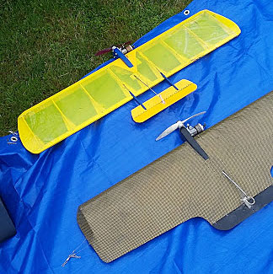 Before…nice & shiny!

After…still shiny, but not so nice…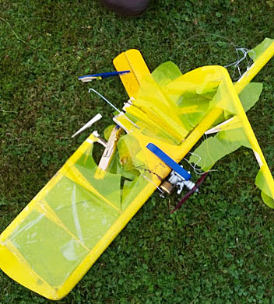
Before the combat….don’t they all look so nice! 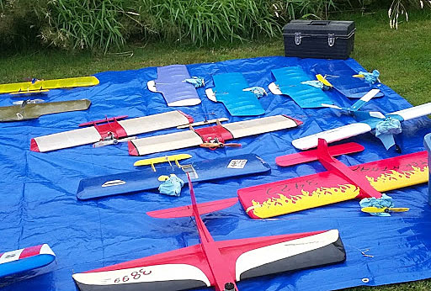

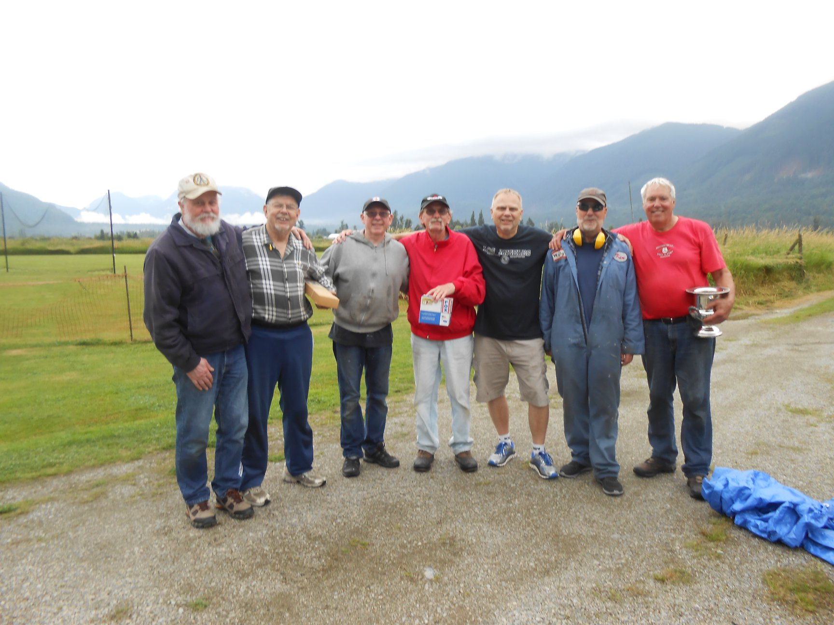
To the victors…the spoils (a.k.a. The usual suspects)

The Winner of Combat Graffiti 2019 was Greg Davis, who took home the silver champagne bucket and a 1958 Fox Black Head Combat Special.
The winner of the Vintage Diesel Combat was Mel Lyne, who took home a Nose Cone Combat kit along with a Cox Medallion .15.
We all left tired, smelly but most of all happy. Happy to see one another, happy to compete, happy to remember friends who have gone before us.

Photo Credits:

Vintage control-line Combat airplanes ready for action. Ken Burdick photo.
Vintage Diesel Combat planes before and after. Ken Burdick photos.
Vintage Contestants R to L: Greg Davis, Ken Burdick, Kelly Crozier, Paul Bedford, Paul Dranfield, Mel Lyne and Larry Lewin. Kathy Lewin photo.

